**Task 1 Network Parameters**

MAC address

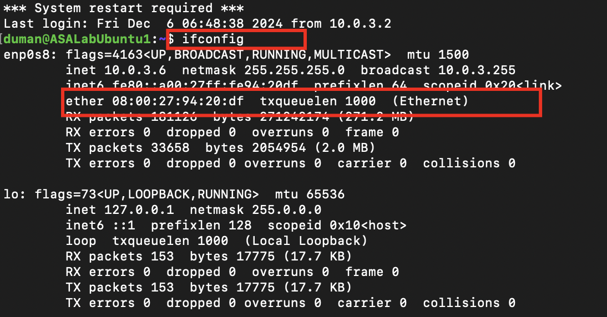

Local ARP table

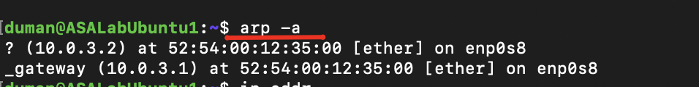

Network interfaces and associated ip addresses

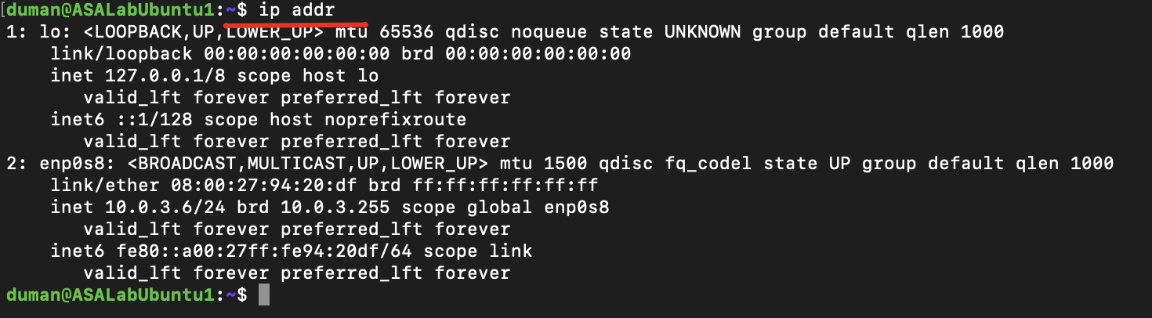

Route table

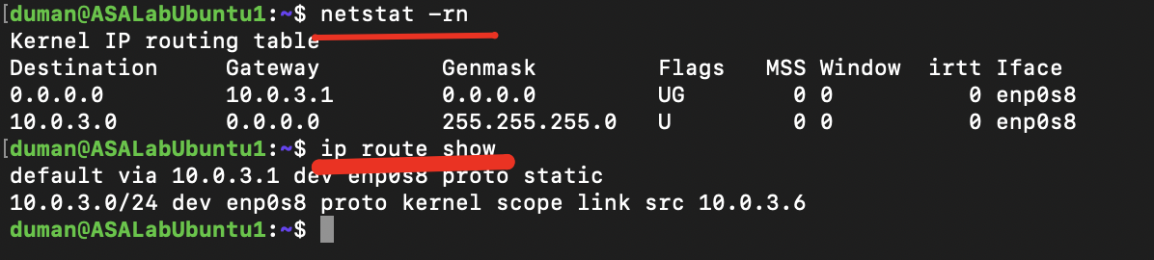

List of open (listening) TCP ports



**Task 2 Network Connectivity**



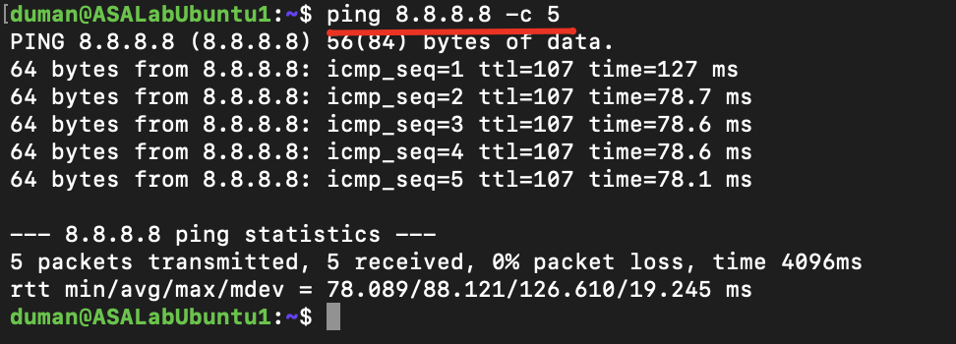



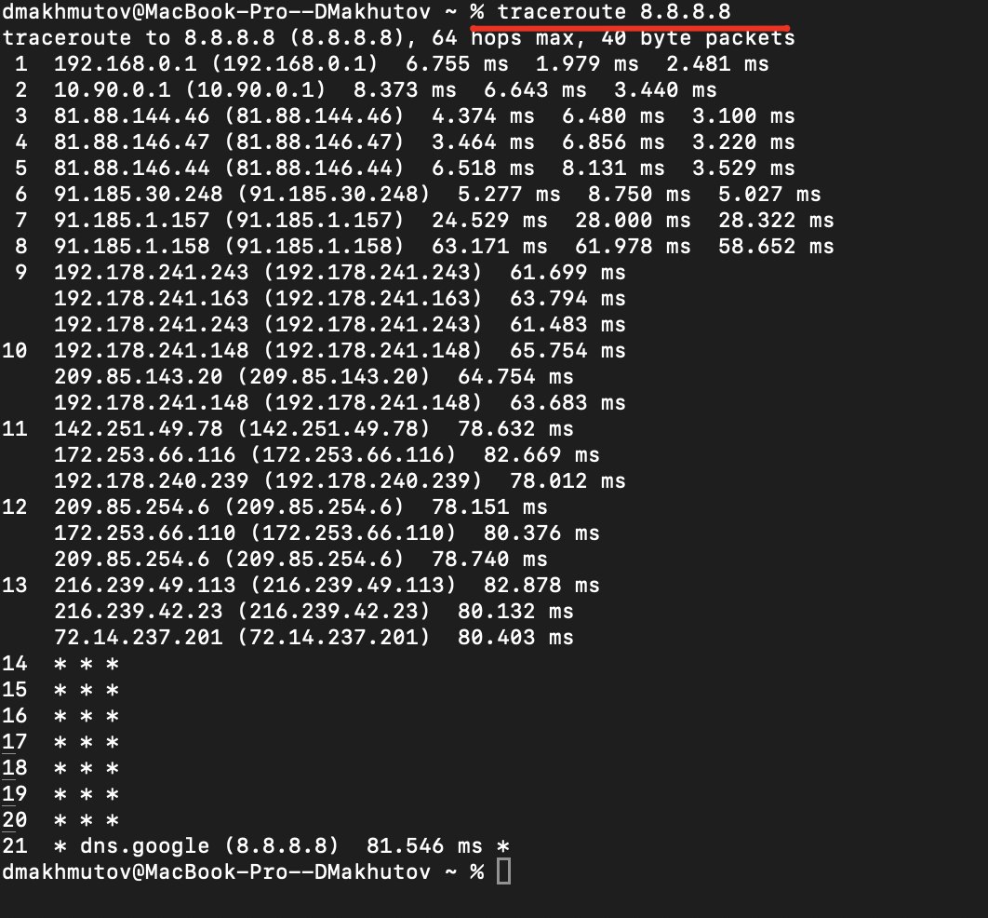

**Task 3 IP Parameters**

1. **Netmask**

In binary, the netmask /26 is:

11111111.11111111.11111111.11000000

In decimal

(128 + 64 + 32 + 16 + 8 + 4 + 2 + 1 = 255) .

(128 + 64 + 32 + 16 + 8 + 4 + 2 + 1 = 255) .

(128 + 64 + 32 + 16 + 8 + 4 + 2 + 1 = 255) .

(128 + 64 = 192)

**Netmask** **is** 255.255.255.192

1. **Network Address**

IP Address in binary: 192.168.0.0 = 11000000.10101000.00000000.00000000

Netmask in binary: 255.255.255.192 = 11111111.11111111.11111111.11000000

Bitwise AND:

11000000.10101000.00000000.00000000

AND

11111111.11111111.11111111.11000000

=

11000000.10101000.00000000.00000000

Convert back to decimal: 192.168.0.0

**Network Address:** 192.168.0.0

1. **Broadcast Address**

IP Address in binary: 192.168.0.0 = 11000000.10101000.00000000.00000000

Set the last 6 bits to 1:

11000000.10101000.00000000.00111111

Convert back to decimal 192.168.0.63

**Broadcast Address**: 192.168.0.63

1. **Number of Hosts**

2^6 - 2 = 64 - 2 = 62

**Number of Hosts**: 62

**Netmask** 255.255.255.192

**Network Address** 192.168.0.0

**Broadcast Address** 192.168.0.63

**Number of Hosts** 62

**Task 4 Local Network Traffic**

**ARP**

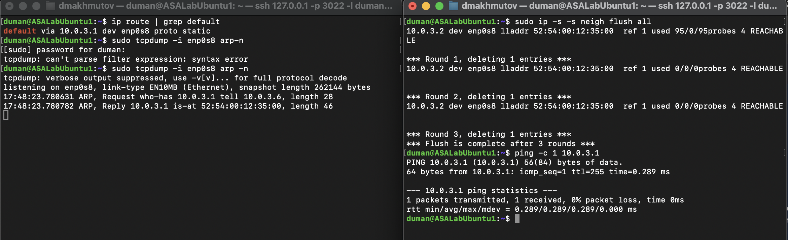

**ICMP**

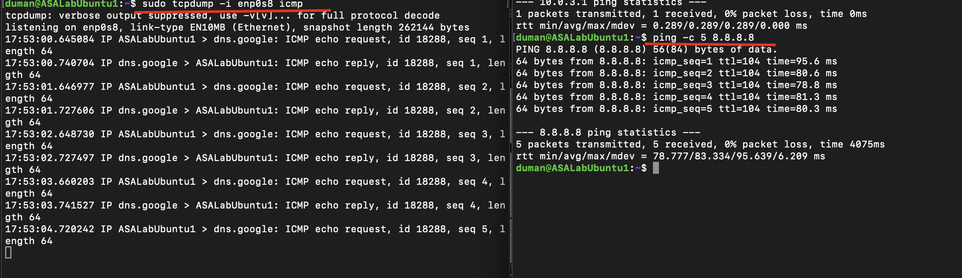

**TCP and HTTP traffic**

